Table of Contents

1. Executive Summary 2
2. Testing Objectives 2
3. Types of Testing 2
3.1 Test Data Used 2
4. Functional Testing 2
4.1 Test Data Used 2
4.2 Validation Checks 4
5. Unit Testing 5
5.1 Unit Testing: 5
5.2 Frameworks and Libraries Used 5
5.3 Test Execution Summary 5
6. API Testing: 6
Example: Testing the /auth/login API 6
Error Handling Validation: 7
7. Database Migration Testing: 9
8. Security Testing: 11
Authentication: 11
Authorization: 11
Input validation: 12
Secrets management: 13
9. Integration Testing: 13

Test Strategy Document

Project Name: Tool Migration – VB Forms to React/FastAPI/Azure
Version: 1.0
Prepared By:
Date:
Approval:

Executive Summary

This document defines the test approach, scope, methodology, environments, and governance for migrating the legacy VB Forms application (on-prem SQL Server) to a modern cloud-based architecture using:
- React.js (Frontend)
- FastAPI (Service Layer)
- Azure SQL (Database)
The objective is to ensure:
- Functional parity
- Data integrity
- Performance stability
- Security compliance
- Cloud reliability
- Regression safety

Testing Objectives

- Ensure 100% business feature coverage
- Validate migrated data accuracy
- Validate service/API correctness
- Confirm cloud deployment readiness
- Detect regression defects early
- Ensure production-grade reliability

Types of Testing

Testing Scope:

S. No. | Type of Testing | Section
1 | Functional Testing (Core) , UI Testing ( React)
2 | Unit Testing (React + Fast API)
3 | API Testing (Fast API Layer)
4 | Integration Testing (Service ↔ Azure SQL)
6 | Data Migration Testing
7 | Security Testing
8 | UAT Testing

Functional Testing

Objective

Goal: Validate features match requirements and legacy behavior.
Includes:
- Feature-based testing: each module/workflow
- Workflow testing: end-to-end business flows
- Role-based testing: permissions & access paths
- Error handling: validation, warnings, exception flows
Key migration focus: Identify “hidden behaviors” in VB Forms (e.g., implicit validations, default values, auto-calculations triggered on field change).

Test Data Used
- Existing Customer Data
Existing customer accounts and program Name were used ,data was compared between VBA and web application.
No Modifications were made for comparison testing
- Modified records for Validation
Few selected customers were intentionally modified, used to validate field checks, business justifications, triggers and submission restrictions.
- Dummy Customer Records
Created new applications for workflow validations, tested end-to-end movement across roles.

Detailed Validation rules and test Scenarios executed during testing are documented in the supporting excel file and can be referred to for complete understanding: SAC VBA DOC.xlsx

Table: Test Data Summary
Vertical | Account Name/Program Name | Testing Purpose | Data Modification
SAC | Union College-Trustees of | UI & Value Comparison | No changes Made
SAC | 4M Capital LTD dbaArteriors Home | UI & Value Comparison | No changes Made
SAC | A’Gaci LLC | UI & Value Comparison | No changes Made
SAC | Alliance Shippers Inc | UI & Value Comparison | No changes Made
SAC | Big boy Restaurants International LLC | UI & Value Comparison | No changes Made
SAC | Tennis Corporation of America | UI & Value Comparison | No changes Made
SAC | True Friends | Mandatory field/Logics/Triggers Validation | Values Modified
SAC | Roedel Companies | Mandatory field/Logics/Triggers Validation | Values Modified
Affinity | Kanha Hotel Programs | UI & Value Comparison | No changes Made
Affinity | Fortress Dental Affinity Program | Mandatory field/Logics/Triggers Validation | Values Modified
Affinity | Big Brother Big Sister of America | Mandatory field/Logics/Triggers Validation | Values Modified
Affinity | Pet Services Program | UI & Value Comparison | No changes Made

Validation Checks
- UI consistency Validation
Verified alignment of screen layouts with legacy VBA system. Confirmed correct field visibility and formatting. Validated mandatory field and associated error messages .
- Data Consistency Validation
Compared field Level Values for identical customer number and program name ,Verified total Premium calculation and derived values for accuracy.
- Business Logic Validations
Validated business rules during save and save & Exit by modifying selected variable inputs and observing system behavior .Confirmed expected trigger behavior
- Workflow Validation
Verified correct application progression across different stages ,confirmed role based access restriction(Underwriter,Director,Admin), verified saved data was available during role transactions
You can find the validation\Internal Testing performed in the following excels:
Excel Link |  | Description
SAC Testing | Data Comparison Validation using same customer number
SAC Bugs | Observations and Business Rule/Form Level issues identified during testing in SAC
Affinity Testing | Validation using same program name
Affinity Bugs | Observations and Business Rule/Form Level issues identified during testing in Affinity

Unit Testing

Objective

Unit test is an automated, isolated test that verifies a small, specific piece of software—such as a single function, method, or class—functions exactly as intended. It checks if defined inputs produce the expected outputs, providing fast feedback to developers, and ensuring code quality early in development.
Objective is to cover >=80% of the total statements as part of unit test cases, while covering negative scenarios as well. We also need to write unit test cases for exception handlings as well.

FastAPI Unit tests:

Unit tests have been implemented for the Python application using the pytest framework. The primary objective of these tests is to validate individual units of code in isolation, enabling the early and cost‑effective identification of defects. All major functions have been covered, including negative and edge-case scenarios, to ensure comprehensive verification of each component independently.

Frameworks and Libraries Used
- Test Framework: pytest
Used as the main testing framework to structure, organize, and execute unit tests.
- Coverage Reporting: pytest-cov
Utilized to measure code coverage and generate detailed coverage reports.
- Data Mocking: pytest-mock
Employed to mock external dependencies, enabling isolated and deterministic test behavior.
- Asynchronous Testing: pytest-asyncio
Used for testing asynchronous functions and ensuring correctness of async workflows.

Test Execution Summary
Below are the details of the test execution and overall coverage results. We have achieved total coverage of 87%, which is more than our objective of covering >=80%.

File | Stmts | Miss | Cover
core/models/sac_policies.py | 47 | 18 | 62%
services/auth_service.py | 121 | 37 | 69%
services/sac/loss_run_distribution_service.py | 33 | 9 | 73%
services/affinity/affinity_agents_service.py | 38 | 9 | 76%
services/sac/sac_account_service.py | 57 | 12 | 79%
services/dropdowns_service.py | 248 | 52 | 79%
services/sac/sac_policies_service.py | 124 | 26 | 79%
core/date_utils.py | 103 | 21 | 80%
services/affinity/policy_type_distribution_service.py | 35 | 7 | 80%
core/db_helpers.py | 157 | 29 | 82%
services/affinity/claim_review_distribution_service.py | 33 | 6 | 82%
services/affinity/loss_run_distribution_service.py | 33 | 6 | 82%
services/sac/claim_review_distribution_service.py | 33 | 6 | 82%
services/sac/deduct_bill_distribution_service.py | 33 | 6 | 82%
services/affinity/affinity_program_service.py | 54 | 9 | 83%
services/sac/sac_affiliates_service.py | 38 | 6 | 84%
services/sac/sac_account_associations_service.py | 93 | 12 | 87%
services/affinity/affinity_policy_types_service.py | 72 | 9 | 88%
core/encrypt.py | 18 | 2 | 89%
services/affinity/claim_review_frequency_service.py | 30 | 3 | 90%
services/affinity/loss_run_frequency_service.py | 30 | 3 | 90%
services/sac/deduct_bill_frequency_service.py | 39 | 3 | 92%
services/sac/loss_run_frequency_service.py | 43 | 3 | 93%
services/sac/claim_review_frequency_service.py | 44 | 3 | 93%
services/sac/hcm_users_service.py | 53 | 3 | 94%
core/config.py | 23 | 1 | 96%
services/validations/affinity_validations.py | 121 | 2 | 98%
__init__.py | 0 | 0 | 100%
api/affinity/affinity_agents.py | 15 | 0 | 100%
api/affinity/affinity_policy_types.py | 12 | 0 | 100%
api/affinity/affinity_program.py | 12 | 0 | 100%
api/affinity/claim_review_distribution.py | 18 | 0 | 100%
api/affinity/claim_review_frequency.py | 13 | 0 | 100%
api/affinity/loss_run_distribution.py | 16 | 0 | 100%
api/affinity/loss_run_frequency.py | 13 | 0 | 100%
api/affinity/policy_type_distribution.py | 13 | 0 | 100%
api/affinity/search_affinity_program.py | 7 | 0 | 100%
api/auth.py | 18 | 0 | 100%
api/dropdowns.py | 15 | 0 | 100%
api/outlook_compose.py | 8 | 0 | 100%
api/sac/claim_review_distribution.py | 18 | 0 | 100%
api/sac/claim_review_frequency.py | 13 | 0 | 100%
api/sac/deduct_bill_distribution.py | 18 | 0 | 100%
api/sac/deduct_bill_frequency.py | 13 | 0 | 100%
api/sac/hcm_users.py | 13 | 0 | 100%
api/sac/loss_run_distribution.py | 18 | 0 | 100%
api/sac/loss_run_frequency.py | 13 | 0 | 100%
api/sac/sac_account.py | 12 | 0 | 100%
api/sac/sac_account_associations.py | 16 | 0 | 100%
api/sac/sac_affiliates.py | 13 | 0 | 100%
api/sac/sac_policies.py | 20 | 0 | 100%
api/sac/search_sac_account.py | 7 | 0 | 100%
core/jwt_handler.py | 21 | 0 | 100%
core/models/__init__.py | 0 | 0 | 100%
core/models/affinity/__init__.py | 6 | 0 | 100%
core/models/affinity/affinity_agents.py | 7 | 0 | 100%
core/models/affinity/affinity_claim_review_frequency.py | 12 | 0 | 100%
core/models/affinity/affinity_distribution.py | 10 | 0 | 100%
core/models/affinity/affinity_loss_run_frequency.py | 13 | 0 | 100%
core/models/affinity/affinity_policy_types.py | 7 | 0 | 100%
core/models/affinity/affinity_program.py | 9 | 0 | 100%
core/models/auth.py | 4 | 0 | 100%
core/models/claim_review_frequency.py | 10 | 0 | 100%
core/models/deduct_bill_frequency.py | 5 | 0 | 100%
core/models/distribution.py | 9 | 0 | 100%
core/models/hcm_users.py | 8 | 0 | 100%
core/models/loss_run_frequency.py | 11 | 0 | 100%
core/models/outlook_compose.py | 11 | 0 | 100%
core/models/sac_account.py | 12 | 0 | 100%
core/models/sac_account_associations.py | 4 | 0 | 100%
core/models/sac_affiliates.py | 5 | 0 | 100%
core/outlook_compose.py | 23 | 0 | 100%
db.py | 39 | 0 | 100%
services/affinity/search_affinity_programs_service.py | 17 | 0 | 100%
services/sac/search_sac_account_service.py | 16 | 0 | 100%
services/validations/__init__.py | 0 | 0 | 100%
Totals | 2346 | 303 | 87%

API Testing:

Objective

Goal: Ensure REST endpoints behave correctly.
Covers:
- Request/response schema validation
- Status codes and error messages
- Authentication/authorization on endpoints
- Pagination, filtering, sorting
- Idempotency (PUT/PATCH), concurrency behavior
Types
- Functional API tests
- Negative tests (invalid payloads, missing headers)
- Contract tests (React ↔ API agreement)

Implementation

All APIs have been validated using Swagger UI, which is provided as part of FastAPI’s built‑in interactive documentation. Swagger UI allows us to manually trigger API endpoints, review request/response structures, and verify both success and error scenarios.

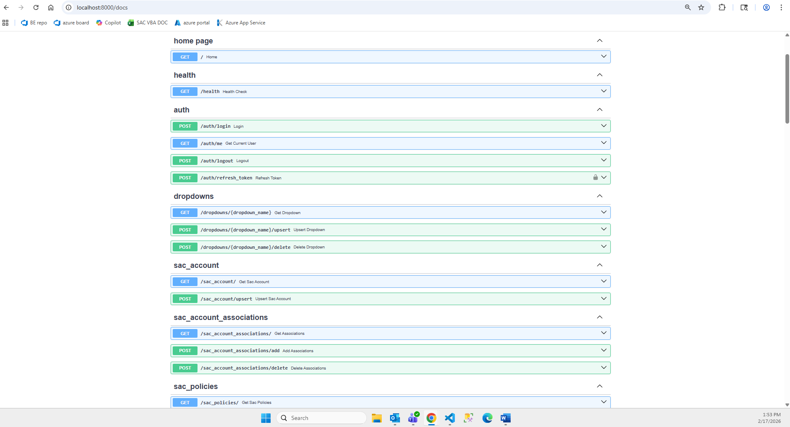

Example: Testing the /auth/login API
- Open Swagger UI in the browser.
- Navigate to the /auth/login endpoint and click the “Try it out” button.
- In the request body text area, provide a payload in the following format:
{
"email": "akshat@dummy.com",
"password": "12345678"
}
You may use any valid user credentials that already exist in the system.
- Click on “execute”. After execution, the response section will display the corresponding success response returned by the API.
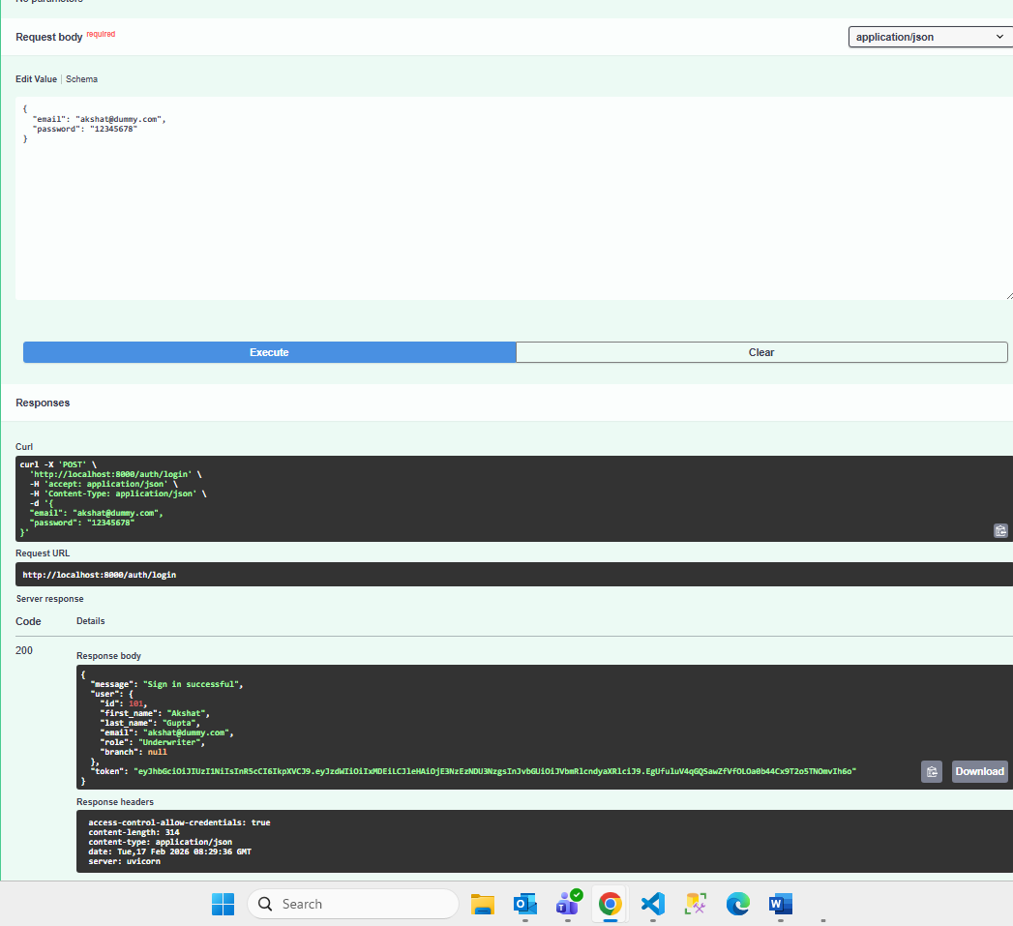

Error Handling Validation:

- When incorrect or invalid values are passed to the API—for example, an incorrect password—the API returns an appropriate error response as configured. This allows us to verify that validation, authentication logic, and exception handling work as expected.
Below we have passed the wrong password:
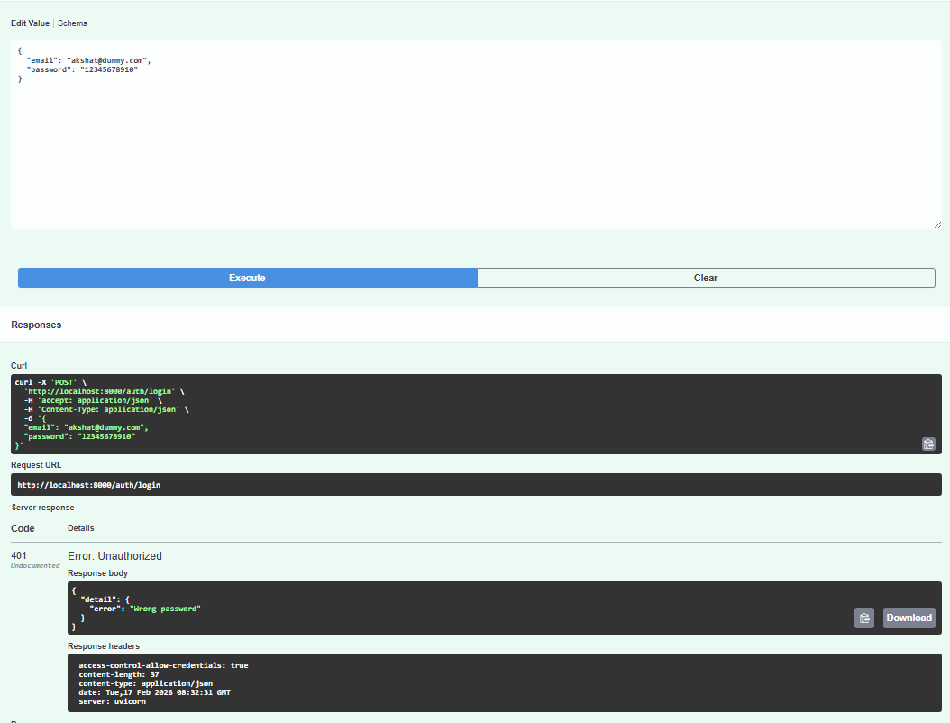

- If we pass details of user which doesn’t exist:
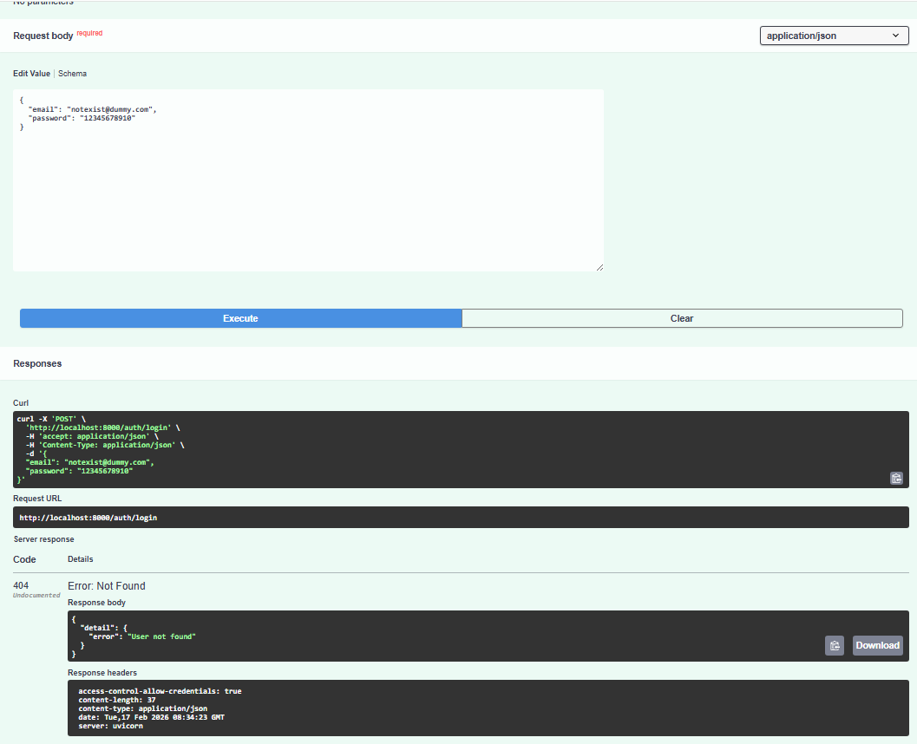

Using Swagger UI, we thoroughly tested all available API endpoints, validating:
- Successful execution paths
- Error responses for invalid input
- Authentication and validation behavior
- Response structure and status codes
This ensures that each API behaves consistently and reliably under both normal and erroneous conditions.

Database Migration Testing:

Objective

If data is migrated from on-prem SQL Server to Azure SQL, test:
- Schema validation
  - Tables, columns, data types, constraints, indexes
- Row count reconciliation
  - Per table counts, per partition/date range
- Data correctness sampling
  - Record-level comparisons for critical entities
- Data integrity
  - Foreign keys, orphan records, duplicate keys
- Business rule reconciliation
  - Aggregates, reports totals, computed fields
- Cutover readiness
  - delta migration strategy, rollback plan, validation scripts

As part of the migration from the on‑premises SQL Server database to the Azure SQL Managed Instance, we carried out comprehensive data migration testing to ensure that all schema objects and data were transferred accurately and completely.

Migration Approach
- A full database export script was generated from the on‑prem SQL Server instance.
This script included:
  - All table definitions
  - Existing row data
  - Constraints (primary keys, foreign keys, indexes, etc.)
- The generated script was executed on the Azure SQL Managed Instance to recreate the database structure and populate it with the migrated data.

Data Validation
To confirm that the migration was successful and no records were lost or altered, we performed row‑count validation on key tables. This involved:
- Running COUNT(*) queries on selected tables in the source (on‑prem) database.
- Running the same COUNT(*) queries on the target (Azure SQL Managed Instance) database.
- Verifying that the row counts matched across environments.
This method provided a quick and reliable way to confirm that data had been fully and accurately migrated.
Below are the details of the tables validated and their respective record counts:

Table Name | Total count in SQL DB | Total count in Azure DB
SAC TABLES
tblAcctSpecial |  | 1208
tblDistribute_ClaimReview |  | 5593
tblDistribute_DeductBill |  | 142
tblDistribute_LossRun |  | 6013
tblLossRunFrequency |  | 15500
tblClaimReviewFrequency |  | 15292
tblDeductBillFrequency |  | 15396
AFFINITY TABLES
tblAcctAffinityProgram |  | 59
tblDist_ClaimRev_AFFIN |  | 163
tblDist_LossRun_AFFIN |  | 219
tblClaimRevFreq_AFFIN |  | 1128
tblLossRunFreq_AFFIN |  | 1128

(have asked deepak to provide data for SQL DB)

Security Testing:
To ensure the security and integrity of the application, several security measures have been implemented and validated. The testing focused on verifying that authentication and authorization mechanisms function as intended, and that access is properly controlled throughout the system.

Authentication:
Authentication for the application is managed through F5 in combination with Azure Active Directory (Azure AD) groups. This setup ensures that only legitimate, directory‑authenticated users are granted access to the application.
For detailed implementation information, refer to Section 6.5 of this document.

Authorization:
Authorization is enforced using Azure AD security groups, which control the level of access granted to authenticated users.
Each role or permission set within the application corresponds to specific Azure AD groups, ensuring that access is provided strictly on a need‑to‑have basis.
For more information on the authorization design and group configurations, see Section 6.4.a.

Input validation:
Extensive input validation has been implemented throughout the application to ensure data accuracy, enforce business rules, and maintain consistency with the legacy VBA application. All fields that previously required validation in the VBA system have been validated in the new application as well. Example Scenario:
Business Requirement:
When an account is marked as “inactive”, the user must provide the following mandatory details:
- Termination Date
- Termination Reason
- Notification Date

Validation Flow:
- Login to the SAC application.
- Set an account's status to Inactive.
- Attempt to save the form without entering the Termination Date.
- The system displays an appropriate error message, and the missing required field is visually highlighted (e.g., the Termination Date field appears with a red border).
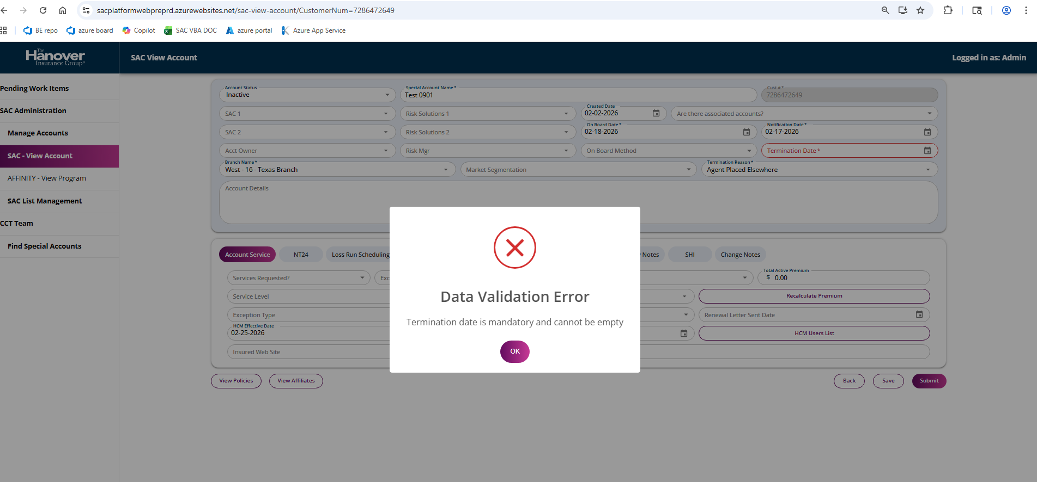
This ensures that users cannot proceed without providing the required information, maintaining the integrity of the data.
Besides status‑based validations, the application also enforces checks on:
- Numeric fields
- Email format validation
- Required dropdown selections
- Context‑based field requirements
- Cross‑field validation rules (where applicable)
These validations collectively ensure that user input is complete, accurate, and aligned with defined business rules before any data is processed or saved.

Secrets management:
All application secrets have been securely stored and managed using Azure Key Vault. This ensures that sensitive information—such as database connection strings, API keys, certificates, and authentication secrets—is isolated from the application code and protected using Azure’s built‑in security controls.
For additional implementation details, configuration steps, and integration workflows, please refer to Section 6.3 of this document.

Integration Testing:
As part of integrating the React and Python-based application into the Azure environment, operational checks and monitoring mechanisms were implemented. These measures help assess the application's health, ensure high availability, and provide automated alerts in case of service degradation or failures.
/health API endpoint:
A dedicated /health endpoint has been implemented to support automated health monitoring. This endpoint plays a critical role in maintaining the application's uptime by enabling Azure to identify and remove unhealthy instances from the load balancer.

Key Behaviors:
- Azure periodically (once per minute) sends a request to the /health endpoint.
- If the endpoint consistently returns HTTP 200, the application instance is considered healthy.
- If the endpoint returns any non‑200 response, it is flagged as unhealthy.
- A continuous failure period of 10 minutes triggers Azure to:
  - Mark the instance as unhealthy
  - Remove it from the load balancer
  - Automatically replace it with a new instance
This mechanism ensures minimal user impact by quickly isolating failing instances and maintaining overall application reliability.
.

